CSC 835

Project management

Department of Computer Science

Term Project Description

EKU’s Registrar Office needs to update student course records after receiving student grades from all of the faculty at the end of each semester. Each faculty member provides the office an Excel file with letter grades (A, B, C, D, or F) of the students who took course(s) with them. The office is asking you to develop a system to manage the data for them. They need you to develop a software system to do the following tasks:

1. Add new grades of courses for each student to a database: The office can gather all the Excel files from the faculty, and put them in a folder. The formats of the names for the folder and Excel files are:

Folder name: “**Grades [Year] [Semester]**”

(Ex., “**Grades 2021 Spring**”, “**Grades 2023 Fall**”)

File name: “**[Course Prefix] [Number] [Year] [Semester]**”

(Ex., “CSC 835 2021 Fall”, “MAT 234 2027 Spring”)

1. Edit a grade for a student: There might be some mistakes in the Excel files provided by the faculty. The system shall allow the office to edit the grade of a course for a student. Editing a grade means changing the grade, deleting the grade, and/or adding a grade to the database.
2. Print a report card (or transcript) for a student: The system shall let them print a report card (or transcript) for a selected student. The report card (or transcript) should list student’s name, id, overall gpa, and a lists of courses with grades that he/she has taken before.

The office has designed the first version the Excel file and database tables. They are not sure if the design is good enough for keeping the data. You will help them to make the database design sound and complete.

Contents of Excel file:

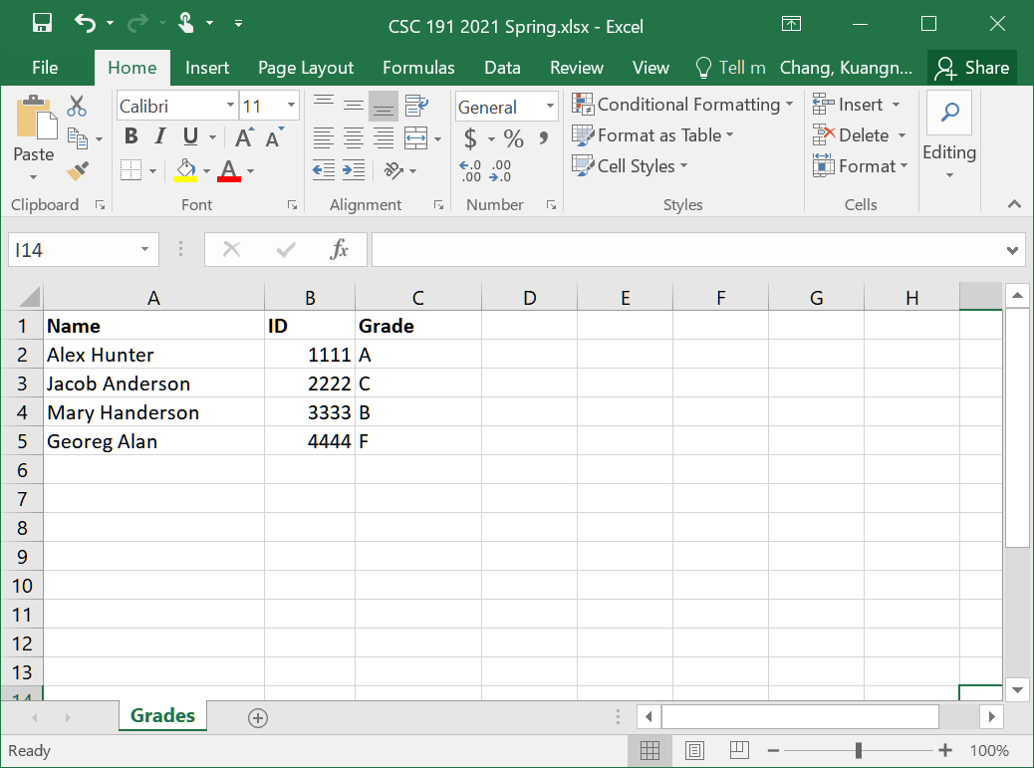

Student Info table:

|  |  |  |
| --- | --- | --- |
| **StudentID** | **Name** | **OverallGPA** |
| 1111 | Alex Hunter | 3.24 |
| 2222 | Jacob Anderson | 2.78 |
| 3333 | Mary Handerson | 3.55 |
| … |  |  |

Student Grades table:

|  |  |  |  |  |  |
| --- | --- | --- | --- | --- | --- |
| **StudentID** | **CoursePrefix** | **CourseNum** | **Grade** | **Year** | **Semester** |
| 1111 | CSC | 191 | A | 2021 | Spring |
| 2222 | CSC | 191 | C | 2021 | Spring |
| 1111 | MUS | 290 | A | 2019 | Fall |
| 3333 | CSC | 191 | B | 2021 | Spring |
| 4444 | CSC | 191 | F | 2021 | Spring |
| …. |  |  |  |  |  |

Course Credit Hours table: (same courses might have different hours due to the changes made by the departments that offered the courses)

|  |  |  |  |  |
| --- | --- | --- | --- | --- |
| **CoursePrefix** | **CourseNum** | **Year** | **Semester** | **Hours** |
| CSC | 191 | 2021 | Spring | 3 |
| MAT | 234 | 2021 | Spring | 4 |
| MUS | 290 | 2019 | Fall | 2 |
| … |  |  |  |  |

**Requirements from the instructor:**

1. We will apply structured analysis and design (not Object-oriented analysis and design) method do implement the project. Although we are going to use C# in Visual Studio for coding, there will be no other classes to create except for the main (default) class. All the functions in the class should be static.
2. We will use the departmental server to create and manage the database system (as we did in CSC 834).
3. C# is very similar to Java. It is your responsibility to learn the langue and Visual Studio on your own. The instructor will help you in debugging and basic uses of the language and the tool.